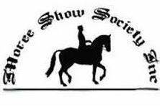
Moree Show Society Showjumping Spectacular
15th & 16th August 2020

Moree Showgrounds
Moree NSW 2400
Entries via Global Entries Online
Entries open Monday 20th July
Closing Wednesday 12th August
Email: emm_horses@hotmail.com
Emily Patterson 0447 000 679
Chery Towns 0428 657 050

Moree Show Society Ring 1: Judge- Ann Mack, Course Designer- Peter Mack
Stance Equitec Ring 2: Judge- TBA, Course Designer- Peter Mack
Saturday 15th August- Moree Show Society Ring 1
Broad sashes for all winners in Ring 1
J1a. MOREE REAL ESTATE - Junior 75cm A2 Entry Fee $8
1st $80 2nd $50 3rd $30 4th $20 5th $10

J1b. MOREE ALUMINIUM & GLASS -Open 75cm A2 Entry Fee $8
1st $80 2nd $50 3rd $30 4th $20 5th$10

J2.AIRCAIR AVIATION - 90cm AM7
1st $80 2nd $50 3rd $40 4th $20 5th$10 Entry Fee $8

J3. PAYNE ELECTRICAL – 1.05-1.10m A2
1st $110 2nd $80 3rd $60 4th $35 5th $15 Entry Fee $10

J4. AIRCAIR AVIATION – Open AM5
1st $180 Rug 2nd $130 3rd $90 4th $60 5th$40 Entry Fee $15

J5. RIDGEWOOD FARMING - Open Speed Championship Entry Fee $15
1st $180 Rug 2nd $130 3rd $90 4th $60 5th$40

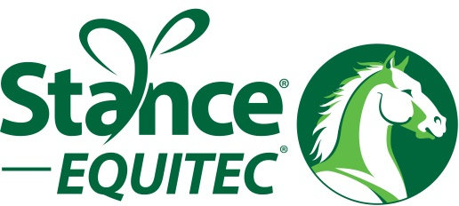

Stance Equitec Performance Products Ring 2
J6. STANCE EQUITEC – 50cm AM5 Entry Fee $5
1st $50 Stance Voucher, Prizes for other places

J7. STANCE EQUITEC – 60cm AM5
1st $50 Stance Voucher, Prizes for other places Entry Fee $5

J8. STANCE EQUITEC - 70cm AM7
1st $50 Stance Voucher, Prizes for other places Entry Fee $5

J9. STANCE EQUITEC – 80-90cm AM7
1st $50 Stance Voucher, Prizes for other places Entry Fee $5

Sunday 16th August- Moree Show Society Ring 1

J10. WE CLEAN IT- Open 80cm A2
1st $80 2nd $50 3rd $30 4th $20 5th$10 Entry Fee $8

J11. MOREE SHOW SOCIETY - Open 100cm A2
1st $110 2nd $80 3rd $60 4th $35 5th $15 Entry Fee $10

J12. LILLYMAN BROS – 110/115cm - Grand Prix
1st $180 Rug 2nd $130 3rd $90 4th $60 5th $40 Entry Fee $15

J13. AIRCAIR AVIATION - Open Grand Prix
1st $350 Rug 2nd $270 3rd $180 4th $120 5th $75 Entry Fee $30

J14. MOREE REAL ESTATE - Junior Six Bar
1st $120 2nd $80 3rd $60 4th $35 5th $15 Entry Fee $10

J15. WHIDDON - Open Six Bar
1st $300 2nd $200 3rd $150 4th $100 5th $50 Entry Fee $20

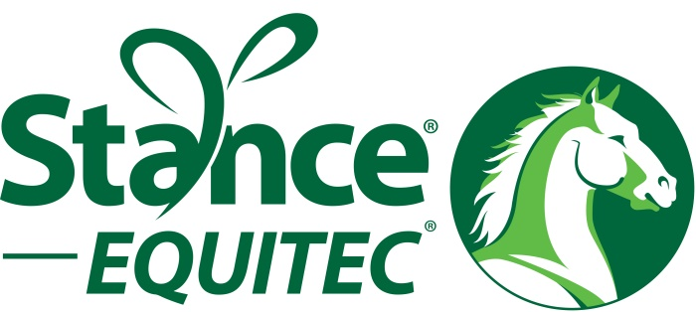

Stance Equitec Performance Products Ring 2
J16. STANCE EQUITEC – 50cm A2 Entry Fee $5
1st $50 Stance Voucher, Prizes for other places

J17. STANCE EQUITEC – 60cm A2
1st $50 Stance Voucher, Prizes for other places Entry Fee $5

J18. STANCE EQUITEC - 70cm A2
1st $50 Stance Voucher, Prizes for other places Entry Fee $5

J19. STANCE EQUITEC – 80-90cm A2
1st $50 Stance Voucher, Prizes for other places Entry Fee $5

Bag of Hyfeed to all class winners in Ring 1 (except six bars)
Champion Overall “Off the Track” Thoroughbred Ring 1 – Sponsored by STUART MAKIM TRANSPORT

Champion Overall “Off the Track” Thoroughbred Ring 2 – Sponsored by MOREE SHOW SOCIETY

Jumping Entries taken via Global Entries Online

Junior Six Bar is for riders under 17 years only

Open Six Bar is for riders over 17 years only

Horses may only start in Junior or Open Six Bar not BOTH

Moree Show Society Arena *Maximum 2 starts per day (not including six bar)*
Stance Equitec Arena –*Maximum 3 starts per day*

*Please note that class J4 & J13 will have MINIMUM starting height of 1.20m*

CHAMPION OVERALL ‘Off the Track” Thoroughbred rules:
Point score will be run and only open to thoroughbred horses competing in the show jumping ring.
Point score will be run as follows 1st 5 points, 2nd 4 points, 3rd 3 points, 4th 2 points, 5th 1 point
If there is a tie in the overall point score winner lower places will also be taken into consideration.
To be eligible for this class your horse must be registered with the Australian Studbook for Racehorses
Winner will be announced at the end of the jumping program Saturday
Race name must be emailed for record purposes
Please note that this point score is free entry

We would like to thank all our sponsors that have made the 2020 jumping program possible!

Moree Real Estate Whiddon Group
Moree Aluminium & Glass We Clean It
AIRCAIR Aviation Lillyman Bros
Payne Electrical Stuart Makim
Ridgewood Farming Transport
Moree Show Society Stance Equitec
HYFEED

This plan and the competition day on August 15th & 16th 2020 going ahead is entirely dependent upon the NSW Government and the restrictions that are in place at the time.
If this weekend has to cancel due to Covid Restrictions all money will be refunded.
Please make sure you read the Moree Show Society Showjumping COVID-19 Operational Plan.
Social distancing must be followed all weekend.
All entries, stabling and camping will be done online via Global Entries Online to follow recommendations from NSW Government & EA Australia.
Waivers will be signed online on Global.
Every person must be accounted for during the competition and check in and out on the register.
Check in will occur beside the judges table with Cheryl Towns or Emily Patterson and must occur within 30 minutes of arrival.
It will be a condition of entry that all persons have read, understood and agree to abide by this plan.
Riders and all other persons attending must provide Emily Patterson via email with the following:
- Full Name and name of any minors that are attending with them
- Telephone Number
- Confirm they have read and understand the plan and will abide by the plan
- Confirm that themselves and any minors attending with them do not have any of the following symptoms:
- Flu like symptoms
- Loss of taste/smell
- Sore throat
- Cough
- Temperature above 37.5 degrees
- Shortness of breath
- Fatigue
Confirm that they and any minors attending have not:
- Been in contact with a person who has tested positive for COVID-19 in the last 14 days
- Returned from overseas in the last 14 days
- Travelled to or returned from Victoria or COVID-19 hotspot in the last 14 days

This information must be emailed to Emily by Wednesday 12th August. If this information is not received and you are not listed on the check in register when you come to sign in, you will be asked to leave the showgrounds.
Emily Patterson Email: emm_horses@hotmail.com
If you are planning on arriving Friday Emily must be notified.
The data collected for this plan will be securely stored and then deleted after 3 months.
If you need any help or have any enquires on entries please contact Emily Patterson.
Moree Show Society will be running a canteen.

