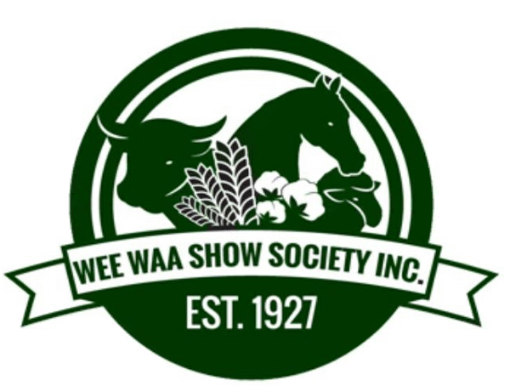

Following the Wee Waa Show Society committee meeting held 5th August 2021, we feel that in the safety of our committee, volunteers and broader community we have no option but to cancel our 2021 show.

The Wee Waa Show has a long and distinguished history and is an event, which many in our local community hold dear. This decision to cancel was not taken lightly; with the current lockdowns coming closer to our community, it is the safest option.

We wish to thank all our Sponsors and supporters of our show for their ongoing support, and will be in contact in due course to discuss what you would like various options.

Having held our Showgirl Judging earlier in July, we will be working on the announcement of our Junior & Senior showgirls, with our Senior Show Girl then going onto represent at the District Zone finals to be held here in Wee Waa in February 2022.

It has been an incredibly tough time over the last few years with the impact of drought in our area. This is yet another setback however, we are a resilient and resourceful bunch of people in the Wee Waa Show Society and with the support of our members and our local community we will bounce back with a bigger and better Wee Waa Show in 2022.

The Executive Committee,
Wee Waa Show Society.

