Henty Show Society Inc.
111th Annual Show Horse Schedule
Saturday 11th February 2017

Henty Show Society: PO Box 77
Henty NSW 2658
To be added to the Horse Schedule email list please register at:

hentyshow@gmail.com

programme also available on the Agricultural Society Council (ASC), Emma’s Showhorses & Greater Hume Shire Council websites
Like us on facebook. Henty Show Society

Henty Show Society PIC code NF321956
HER Number: 7384

RINGMASTERS: Bert Stevens & Garry Small
0269 293 387 040 230 9248
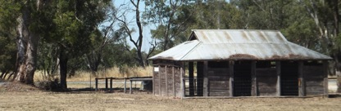
WELCOME TO HENTY SHOW 2017
HENTY SHOW horse rules

Fun Ring start 8.30 all other rings start 9.00 am

Judging times for supreme classes is subject to completion of other classes.

Competitors and spectators are required to keep the access lane clear and not loitre.

Dogs must not enter the area bounded by the chain wire fence (the oval), at all other times they must be on a leash or be held.

FUN RING: No Pony Club Uniforms Long boots or jackets to be worn in Fun ring!!!

Registration papers must be produced upon request in all breed rings Owners/Exhibitors must be current financial members of the Breed Society their horse/horses are registered with. All height specifications within schedule must be obeyed.

SHOWHUNTERS: If a horse competes in open height classes, e.g. Hack ring they are then not eligible to enter Show hunter classes & vice versa.

All riders must wear regulation attire, approved safety helmets to be worn when riding.
PIC numbers MUST be entered as must Horse description and venue of last event entered.
It’s new so please enter your email address where requested
Stallions must be handled by persons 18yrs or older and must be bitted.

Random swabbing may be carried out under ASC requirements.
Any breach will be referred to the ASC Disputes/Disciplinary Committee.

Protests or disputed results must be in writing & received no later then end of the ring in question, signed and include $50 fee and presented to the Ringmaster, if found to be frivolous or not upheld this fee will be forfeited. Judges must not be approached by competitor or member of the public
except through the Ringmaster.

IMPROPER BEHAVOUR: Outside assistance to competitors by word, by radio or by any other means in Horse ring events will NOT be permitted. If in breech of this ruling names of competitors and their exhibits may to be given to A.S.C.

Any competitor found to have breached the ASC disputes and disciplinary regulations will be investigated by the ASC Disciplinary Committee.

FUN RING ENTRY FEE $1.00
SHOWJUMPING & DRESSAGE $5.00
ALL OTHER RINGS $2.00
Sponsored Prize money only, ribbons to 3rd.
Entry to rings by tickets available at arena gate and are not redeemable at end of day.
Indemnity forms filled in and handed in at arena gate in return for wrist bands WHICH MUST BE WORN!

Indemnity/Waiver forms must be signed by all competitors and for all competitors under 18 by their parent/guardian and wrist bands must be worn as proof of compliance.

RING ORDER

Ring 1- Fun Ring Judge: Maureen Janetzki

Ring 2 – Ponies & Children’s Riding Judge: Dinka Ireland

Ring 3- Galloways, Show Hunters Judge: Louise Tempany

Ring 4- Hacks, Adult riding Judge: Vicki Brown

Ring 5- Arabians & Harness Judge:

Ring 6- Stud Ponies Judge: Merle Rodwell

Ring 7- Australian. Stock Horses Judge:

Ring 8- Coloured Horses Judge: Kathleen Johnston

Ring 9-Adult Riding “HRCAV” Judge:

Ring 10- Show Jumping: Border & District Show Jumping Club
Ring11- Dressage Judge:

Failure to fully complete horse handling participants risk acknowledgement & waiver form will result in your placings not being forwarded to the ASC & RAS.

We would like to thank our valued sponsors for Henty Show 2016

Aberdeen Poll Dorset Stud-Simon & Melissa Male. Henty
Albury Wodonga Pest Control, Andrew Fagan
Ascot Meats. Albury
ASH Society Riverina Branch
Border & District Showjumping Club
Corowa Chaff Mills. Terry & Anne Mardling
Culcairn Butchery. Stewart Weily. Culcairn
Dennis & Susan Kane. Henty
Dilutes Australia NSW & ACT Branch
Dylanglen Connemara Stud Marion & John Adams. Rand
Federation Bulk Haulage Cherrie Mills Corowa.
Garry & Kerry Small. Henty
Goulburn Murray ASHS Branch
Horseland Albury Alison Sim
Jirrima Performance Horses, Kay Harding
Paint Horse Association of Australia
Palomino Society Inc.
R & B Dick Wahgunyah ‘Arabs’
Riding Ponies RPSBS
Riverina Saddlery Mat Murray
Riverina Water
Rutherglen Veterinary Clinic. Dr Penny Reeves
Saddleworld Albury Kim Johnston
Saddleworld Wagga Wagga Sylvia & Marina Douglas
Southwest Stockfeeds Brian Smith. Wagga Wagga
Sugargum Connemara Stud Janene Leslie. Lake Cargelligo
The Land (Fairfax Media)

Without these generous sponsors there would be few trophies, prizes and gift vouchers for you to win. Please say thankyou when you see them because we need their help too.

RING 1 FUN RING Judge. Maureen Janetzki
Start 8.30 am Start 8.30am Start 8.30am

PONY CLUB UNIFORMS & LONG BOOTS MUST NOT BE WORN COMPETITORS UNABLE TO COMPETE IN ANOTHER RING.!!
101. Handler under 10yrs -
102. Rider 6yrs & under [may be led]
103. Rider 7 & under 10 yrs – Prize donated by D & S Kane
104. Rider 10 & under 13yrs – Prize donated by D & S Kane
105. Rider 13 & under 15yrs – Prize donated by D & S Kane
106. Rider 15 & under 18yrs – Prize donated by D & S Kane
107. A pair of riders under 13yrs
108. A pair of riders 13 & under 18yrs
109. A Family of riders [Min. 1 Adult]
110. Section Four of riders under 18yrs
111. Bareback rider under 18yrs
112. Quietest pony
113. Fancy dress
114. Pony/Horse with prettiest head
115. Pony/Horse with fastest walk

Prizes donated by Horseland Albury and are to be awarded at the judges discretion.

RING 2: PONIES, Children’s Riding
Judge: Dinka Ireland
LED
201. Led pony n.e. 11.2
202. Led pony over 11.2h n.e. 12hh
203. Led pony over12hh n.e.12.2hh
204. Champion & Reserve Led Pony n.e. 12.2H
205. Led pony over 12.2hh n.e. 13hh
206. Led pony over 13 hh n.e. 13.2hh
207. Led pony over 13.2 & n/e 14
208. Champion & Reserve Led Pony over 12.2 & n/e 14hh
Prize Headstall & Lead Set Horseland Albury
RIDDEN
209. Novice ridden pony n.e. 14hh
210. Ridden pony n.e. 11.2hh
211. Ridden pony over 11.2h n.e. 12.2hh
212. Ridden pony over 12.2h n.e. 13hh
213. Childs Pony
214. Champion & Reserve Ridden Pony n.e. 13hh
215. Ridden pony over 13hh n.e. 13.2hh
216. Ridden pony over 13.2hh n.e. 14hh
217.Childs Pony over 13hh n.e. 14.2hh
218. Champion & Reserve Ridden Pony n.e. 14hh
219. Best-Educated pony n.e. 14hh
220. Pleasure pony [Snaffle bit only].
CHILDRENS RIDING
221. Boy rider 6yrs & under [may be led] if led can not compete for Champion
222. Novice Boy rider 6yrs & under 12yrs
223. Boy rider 6 & under 9yrs
224. Boy rider 9 & under 12yrs
225. Champion & Reserve Boy rider under 12yrs
226. Novice Boy rider 12yrs & under 17yrs
227. Boy rider 12 & under 15yrs
228. Boy rider 15 & under 17yrs
229. Champion & Reserve Boy rider under 17yrs
230. Girl Rider 6yrs & under [may be led] if led can not compete for Champion
231. Novice Girl Rider 6yrs & under 12yrs
232. Girl rider 6 & under 9yrs
233. Girl rider 9 & under 12yrs
234. Champion & Reserve Girl Rider under 12yrs
235. Novice Girl Rider12yrs & under 17yrs
236. Girl rider 12 & under 15yrs

237. Girl rider 15 & under 17yrs
238. Champion & Reserve Girl Rider 12 & under 17yrs
239. SUPREME JUNIOR RIDER under 17yrs
Voucher The Land Newspaper


Brian Smith
11 Morong St Wagga Wagga NSW 2650
Phone 026921 4151 Fax 016921 8276


Allison Sim
Albury Horseland
592 Hume St, Albury
6041 3310
albury@horseland.net.au
RING 3 GALLOWAYS/HUNTERS Judge: Louise Tempany
LED
301. Led Galloway over 14 n/e 14.2
302. Led Galloway over 14.2 n/e 15
303. Champion & Reserve Led Galloway 14h n.e. 15hh

RIDDEN
304. Novice ridden Galloway over 14 n.e. 15hh
305. Ridden Galloway over 14h n.e. 14.2hh
306. Ridden Galloway over 14.2h n.e. 15hh
307. Open Galloway over 14h n.e. 15hh Horses must not have won 1st in
height classes today.
308. Gentleman’s Galloway
309. Ladies Galloway
310. Childs Galloway
311. Champion & Reserve Ridden Galloway
Prize Headstall & Lead Set Albury Horseland

SHOWHUNTERS
312. Led Show hunter Pony n.e. 12.2hh
313. Led Show hunter Pony over 12.2h n.e. 14hh
314. Led Show hunter Galloway over 14h n.e. 14.2hh
315. Led Show hunter Galloway over 14.2h n.e. 15hh
316. Led Show hunter Hack over 15h n.e. 16hh
317. Led Show hunter Hack over 16h
318. Champion & Reserve Led Show Hunter
Prize Southwest Stockfeeds Wagga

319. Ridden Show hunter Pony n.e. 12.2h
320. Ridden Show hunter Pony over 12.2h n.e. 13hh
321. Ridden Show hunter Pony over 13h n.e. 14hh
322. Childs Show hunter Pony n.e 14h-Rider under 12yrs. First place getters (riders or horses) classes 319, 320 & 321 unable to compete.
323. Champion & Reserve Ridden Show Hunter
324. Ridden Show hunter Galloway over14h n.e. 14.2h
325. Ridden Show hunter Galloway over 14.2h n.e. 15h
326. Childs Ridden Show hunter Galloway n.e 15h
327. Ladies Ridden Show hunter Galloway n.e 15h
328. Gentleman’s Ridden Show hunter Galloway n.e 15h
329. Champion & Reserve Ridden Show Hunter
330. Ridden Show hunter Hack over15h n.e. 16h
331. Ridden Show hunter Hack 16h & over
332. Childs Show Hunter
333. Ladies Show Hunter
334. Gents Show Hunter
335. Champion & Reserve Ridden Show Hunter
336. Supreme Ridden Show Hunter
Bag of Chaff by Ascot Meats.

ASCOT MEAT PRODUCTS Pty. Ltd.
54 Kelly St. Wodonga Vic. 3690
(02) 60 550 263

RING 4: HACK’S, Judge: Vicki Brown

Sylvia & Marina Douglas
99 Edward St. Wagga 2650
0269 214 077 fax 0269 215 794
saddleworldwagga@bigpond.comm

LED
401. Led Hack over 15h n.e. 15.2hh
402. Led Hack over 15.2h n.e. 16hh
403. Led Hack over 16h n.e. 16.2hh
404. Led Hack over 16.2h
405. Champion & Reserve Led Hack over 15h
$25 voucher donated by Saddleworld. Wagga

RIDDEN
406. Novice Ridden Hack over 15h
407. Ridden Hack over 15h n.e. 15.2hh
408. Ridden Hack over 15.2h n.e. 16hh
409. Ridden Hack over 16h n.e. 16.2hh
410. Ridden Hack over 16.2h
412. Childs Hack
413. Ladies Hack
414. Gentleman’s Hack
415. Champion & Reserve Hack over 15h

THOROUGHBREDS
LED
416. Led Mare or Filly
417. Led Gelding
418. Champion/Reserve Led Thoroughbred
RIDDEN
419. Ridden Mare 15 hands and under 16 hands
420. Ridden Mare over 16 hands
421. Ridden Gelding 15 hands and under 16 hands
422. Ridden Gelding over 16 hands
423. Champion/Reserve Ridden Thoroughbred
$25 voucher to Saddleworld Albury donated by Henty Show Society
ADULT RIDING
424. Novice Gent Rider 17yrs and over
425. Gent Rider 17 & Under 21 yrs
426. Gent Rider 21 & Under 40 yrs
427. Gent Rider 40 & over
428. Champion & Reserve Gent rider
Prize Headstall & Lead Set ‘Horseland’ Albury

432. Novice Lady Rider 17yrs & over
433. Lady Rider 17yrs & under 21yrs
434. Lady Rider 21yrs & under 40yrs
435. Lady Rider 40yrs & over
436. Champion & Reserve Lady Rider
437. SUPREME LED EXHIBIT [From Ring’s 2, 3 & 4].
438. SUPREME RIDDEN EXHIBIT [From Ring’s 2, 3 & 4].
439. SUPREME ADULT RIDER OF SHOW [From Ring 3 & 4]

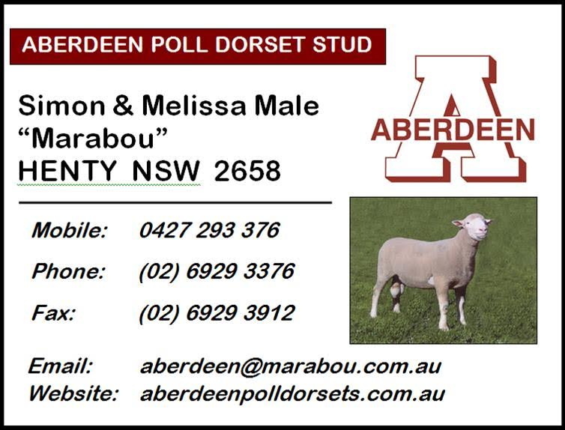

Ring 5 ARABIANS Judge:
LED
501. Led Purebred Filly 3yrs & under
502. Led Purebred Mare
503. Led Purebred Gelding 3yrs & under
504. Led Purebred Gelding
505. Led Purebred Colt 3yrs & under
506. Led Purebred Stallion any height
507.Champion & Reserve Purebred Exhibit
$25 Voucher to Horseland Albury donated by R & B Dick: Farrier Wahgunyah
DERIVATIVES
508. Led Filly 3yrs & under
509. Led Gelding 3yrs & under
510. Led Colt 3yrs and under.
514. Led Derivative n.e. 14.2hh
515. Led Derivative 14.2h n.e. 15.2hh
516. Led Derivative 15.2h & over
517. Champion & Reserve Led Derivative $25 Voucher to Horseland Albury Champion Anglo - donated by: R & B Dick: Farrier Wahgunyah
COROWA CHAFF MILL
Terry and Anne Mardling
Riverina Highway
Corowa
Local Agents
Whitlocks. Tom & Letitia
Railway Pde.
Henty 0269 293 297
RIDDEN
518. Ridden Derivative n.e. 15hh
519. Ridden Derivative 15h n.e. 16hh
520. Ridden Derivative 16h & over
521. Champion & Reserve Ridden Derivative
522. Ridden Purebred Mare
523. Ridden Purebred Gelding
524. Ridden Purebred Stallion
525. Champion & Reserve Ridden Purebred $25 Voucher to Horseland Albury Champion Anglo - donated by: R & B Dick: Farrier Wahgunyah
526. Best educated Arabian
527. Pleasure Arabian [snaffle bit only]
528. Arabian Show costume
529. Arabian Native costume

HARNESS Judge: Bert Stevens
530. Turnout- Viceroy
531. Turnout- Sulky
532. Turnout- Four wheel
533. Turnout- Shetland
534. Champion & Reserve Turnout
535. Novice Horse/pony in harness
536. Shetland in harness
537. Pony in harness n.e. 14hh [excludes Shetlands & Hackneys]
538. Horse in harness 14h & over [excludes Hackneys]
539. Champion & Reserve Horse/Pony in Harness
540. Hackney in harness n.e. 12.2hh
541. Hackney in harness 12.2 n.e. 14.2hh
542. Champion & Reserve Hackney in Harness
Bag of Chaff by Corowa Chaff Mills

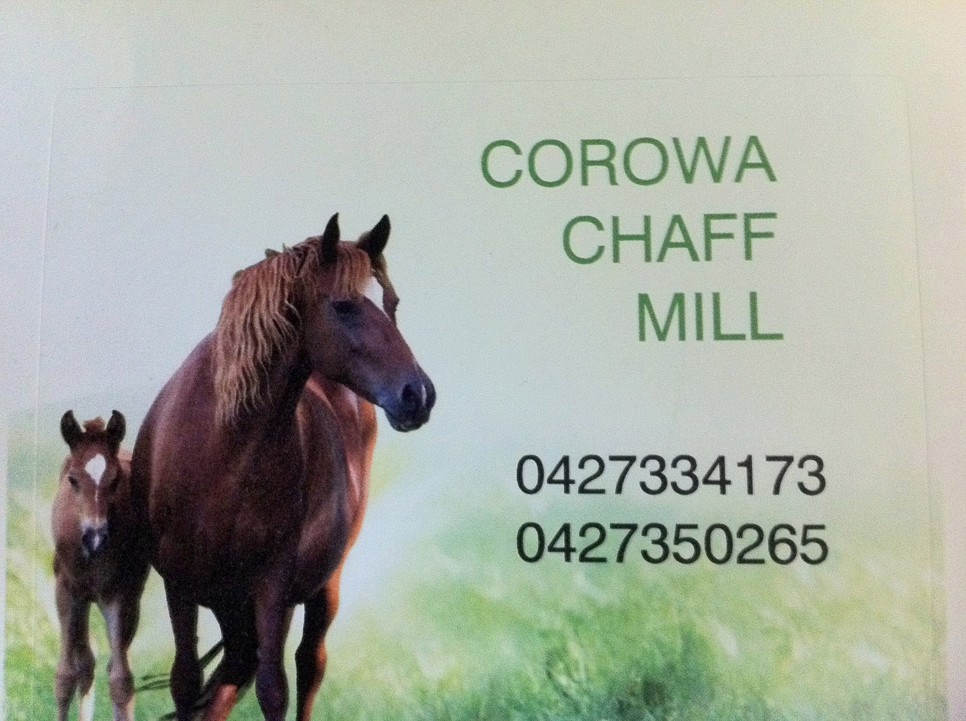

RING 6 STUD PONIES Judge : Merle Rodwell
LED SHETLANDS
601. Led Shetland M/F n.e. 8.2hh
602. Led Shetland M/F 8.2h & Over
603. Led Shetland Stall/Colt n.e. 8.2hh
604. Led Shetland Stall/Colt 8.2h & Over
605. Led Shetland Gelding
606.Champion & Reserve Led Shetland – Trophy donated by
Lentara Shetland Stud.

LED A.P.S.B. PONIES
607. Led A.P.S.B. n.e. 11.2hh
608. Led A.P.S.B. 11.2h n.e. 12.2hh
609. Led A.P.S.B. 12.2h n.e. 13.2hh
610. Led A.P.S.B. 13.2h n.e. 14hh
611.Champion & Reserve A.P.S.B Pony

LED A.W.S.B PONIES
612. Led Welsh n.e. 11.2hh
613. Led Welsh 11.2 n.e. 12.2hh
614. Led Welsh 12.2 n.e. 13.2hh
615. Led Welsh 13.2 n.e. 14hh
616. Champion & Reserve Pony W.P.& C. Society
$25 donated by Federation Bulk Haulage. Corowa
617. Led Riding Pony n.e. 14.2hh
618. Led Saddle Pony n.e. 14.2hh

CONNEMARAS - Sponsored by Dylanglen & Sugargum Studs.

LED CONNEMARAS
619. Led Connemara Mare/Filly
620. Led Connemara Stallion/Colt
621. Led Connemara Gelding
622.Champion & Reserve Led Connemara $25 Dylanglen Connemara Stud
623. Led Part bred Connemara Mare/filly [not eligible for Supreme].
624. Led Part bred Connemara Male [not eligible for Supreme].
625. Champion/Reserve Part bred Connemara
$25 Sugargum Connemara Stud
LED WELSH PART BRED
626. Welsh Part Bred n.e. 12.2 h
627. Welsh Part Bred 12.2 h n.e. 13.2h
628. Welsh Part Bred over 13.2 h
629. Champion Reserve Welsh Part Bred .

LED APSB Riding Pony Part Bred
630. APSB Riding Pony Part Bred n.e. 12.2h
631. APSB Riding Pony Part Bred 12.2h n.e. 13.2h
632. APSB Riding Pony Part Bred over 13.2h
633. Champion Reserve APSB Riding Pony Part Bred
634. SUPREME LED STUD PONY
$25 voucher donated by Sugargum Stud to Riverina Saddlery Wagga
RIDDEN
635. Ridden Shetland Mare/Geld n.e. 8.2hh
636. Ridden Shetland Mare/Geld 8.2h & over
637. Ridden Shetland Stallion
638. Champion & Reserve Ridden Shetland
639. Ridden A.P.S.B. pony n.e. 11.2hh
640. Ridden A.P.S.B. pony 11.2 n.e. 12.2hh
641. Ridden A.P.S.B. pony 12.2 n.e. 13.2hh
642. Ridden A.P.S.B. pony 13.2 n.e. 14.2hh
643. Champion & Reserve A.P.S.B Pony $25 donated by Federation Bulk Haulage Corowa

644. Ridden Welsh pony n.e. 11.2hh
645. Ridden Welsh pony 11.2 n.e. 12.2hh
646. Ridden Welsh pony 12.2 n.e. 14hh
647. Champion & Reserve Ridden Pony
Sash by Welsh Pony & Cob SOCIETY
$25 donated by Federation Bulk Haulage Corowa

648. Ridden Riding Pony n.e. 12.2hh
649. Ridden Riding Pony 12.2 n.e. 14.2hh
650. Ridden Saddle Pony n.e. 12.2hh
651. Ridden Saddle Pony 12.2 n.e. 14.2hh
652. Champion & Reserve Riding/Saddle Pony
$25 donated by Federation Bulk Haulage Corowa

653. Supreme Ridden Stud Pony

654. Ridden Connemara $15 donated by Dylanglen Connemara Stud

RING 7 JUDGE: TBA
All horses to be registered & riders to be current ASHS members. Membership cards & registration papers to be shown.

AUSTRALIAN STOCK HORSES
LED 701. Led 3yrs & under (any sex)
702. Led mare 4yo
703. Led Gelding 4yo
704. Led Stallion 4yo
705. Led Mare 5yrs & over
706. Led Gelding 5yrs & over
707. Led Stallion 5yrs & over
708. Champion & Reserve Led ASH
Sashes by Australian Stock Horse Society
RIDDEN
709. ASH 3yo & under (any sex)
710. ASH Mare 4yo
711. ASH Gelding 4yo
712. ASH Stallion 4yo
713. ASH Mare 5yo & over
714. ASH Gelding 5yo & over
715. ASH Stallion 5yo & over
716. Champion & Reserve Champion RIDDEN ASH
Sashes by Australian Stock Horse Society
$25 Voucher Saddleworld Wagga Wagga
WORKING.
717. ASH 3yrs & under (any sex)
718. ASH Mare 4yo
719. ASH Gelding 4yo
720. ASH Stallion 4yo
721. ASH Mare 5yo & over
722. ASH Gelding 5yo & over
723. ASH Stallion 5yo & over
724. Champion & Reserve Working ASH
Sashes by Australian Stock Horse Society,
Bag Chaff Corowa Chaff Mill

725. SUPREME RIDDEN ASH.
(Champion Working & Champion Ridden eligible)
$50 cash Goulburn Murray ASHS Branch
726. ASH Turnout Youth under 18yrs
727. ASH Turnout Open. Class 730 competitors ineligible to compete.
YOUTH
728. Youth Ridden Hack under 13 yrs
729. Youth Ridden Hack 13 yrs & under 18 yrs
730. Youth Working under 13 yrs
731. Youth Working 13 yrs & under 18 yrs
732. CHAMPION & RESERVE YOUTH
$50 Voucher The Land Book Co.
STATION CLASSES
733. 3yo & under Station Horse (any sex)
734. 4yo Station Horse (any sex)
735. 5yo & over Station Horse (any sex)
736. Youth Rider under 18yrs Station Horse
$25 voucher donated by Riverina Saddlery Wagga Wagga
734. Led Quarter Horse Gelding
735. Led Quarter Horse Mare
Champion Reserve Quarter Horse
Kabneleh Arabian Stud
PLEASE SUPPORT OUR SPONSORS AS HENTY SHOW SOCIETY NEEDS THEIR SUPPORT TOO
Riverina Saddlery
21 Copland St. Mobile: 0407722089
Wagga Wagga NWS 2650 Australia
matmurray@live.com.au
www.mathewmurray.com.au

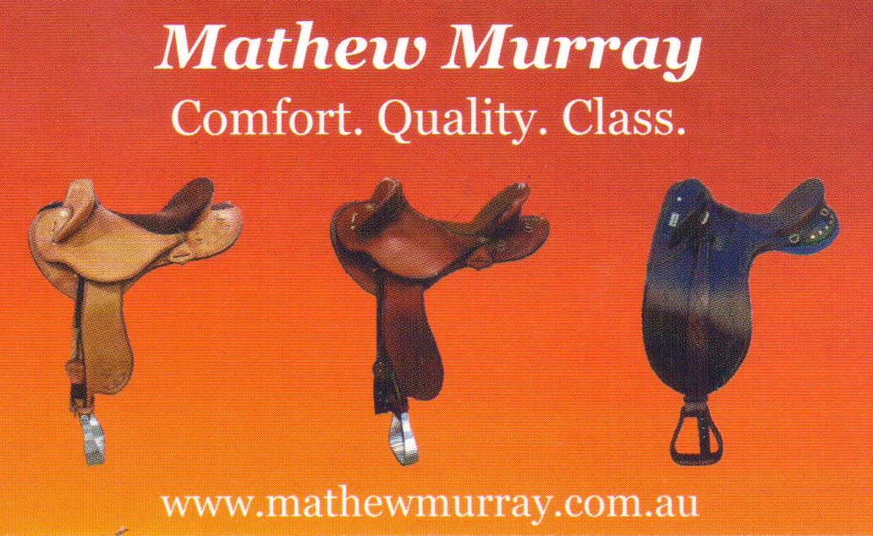
RING 8, COLOURED HORSES Judge: Kathleen Johnston
LED PALOMINOS
801. Best presented
802. Best Mane & Tail
803. Best Coat & Colour
804. Led 3yrs & under
805. Led Mare
806. Led Gelding
807. Led Stallion
808. Champion & Reserve Led Palomino Ribbons NSW Palomino Society $25 voucher donated by Saddleworld. Wagga Inc. LED BUCKSKINS
809. Led Mare/filly
810. Led Gelding
811. Led Stallion
812. Champion & Reserve Led Buckskin. Dilutes Australia NSW & Bag Chaff-Corowa Chaff Mill ACT
LED PAINTS
813. Led Mare/Filly
814. Led Gelding
815. Led Stallion
816. Champion & Reserve Led Paint. Sashes by Paint Horse Association
$25 voucher to Saddleworld Albury donated by Henty Show Society
LED APPALOOSAS
817. Led Mare/Filly
818. Led Gelding
819. Led Stallion
820. Champion & Reserve Led Appaloosa
Bag Chaff – Corowa Chaff Mill
LED PINTOS
821. Led Mare/Filly
822. Led Gelding
823. Led Stallion
824. Champion & Reserve Led Pinto
825. SUPREME LED COLOURED EXHIBIT – Sash donated by:
Dilutes Australia NSW ACT Branch.
Bag Chaff – Corowa Chaff Mill
826. Led Perlino [Unable to compete for Supreme]
827. Led Roan [Unable to compete for Supreme]

RIDDEN
828. Ridden Palomino Mare
829. Ridden Palomino Gelding
830. Ridden Palomino Stallion
831. Champion & Reserve Ridden Palomino – Sashes donated by
NSW Palomino Society NSW $20 Voucher by Saddleworld Albury
832. Ridden Buckskin Mare
833. Ridden Buckskin Gelding
834. Ridden Buckskin Stallion
835. Champion & Reserve Ridden Buckskin – Sashes donated by:
Dilutes Australia NSW ACT Branch.
Bag Chaff Corowa Chaff Mill
836. Ridden Paint Mare
837. Ridden Paint Gelding
838. Ridden Paint Stallion
839. Champion & Reserve Ridden Paint. Sashes donated by:
Paint Horse Association
$20 Voucher by Saddleworld Albury

840. Ridden Appaloosa Mare
841. Ridden Appaloosa Gelding
842. Ridden Appaloosa Stallion
843. Champion & Reserve Ridden Appaloosa
$20 Voucher by Saddleworld Albury

844. Ridden Pinto Mare
845. Ridden Pinto Gelding
846. Ridden Pinto Stallion
847. Champion & Reserve Ridden Pinto
848. SUPREME RIDDEN COLOURED EXHIBIT –
Sash donated by: Dilutes Australia NSW ACT Branch.
$20 Voucher by Saddleworld Albury
849. Ridden Perlino
850. Ridden Roan
RING 9
Gerogery Equestrian Club
HRCAV Official Show Ring @ Henty Ag Show
Saturday February 11th 2017
HOSTED BY: Gerogery Equestrian Club
VENUE: Henty Agricultural Show – Main Arena
STARTS: 9 am sharp (Performance cards to be presented 30 minutes prior to competing)
JUDGE: TBA
CARD STEWARD: Katrina McMaster
FEES: $35 block entry - PRE-ENTRY
$50– ENTRY ON THE DAY
ENTRIES CLOSE: Friday 3rd February 2017
ENTRIES TO kjmcmaster1@hotmail.com OR
Event Secretary, Gerogery Equestrian Club, “Edolston” Walbundrie NSW 2642
Entries Must Be On Official Standard HRCAV Entry Form
CHEQUES PAYABLE: Gerogery Equestrian Club.
Or direct debit BSB 640-000 ACCT 561544516
PRIZES: Sashes to 6th for SOP, Sashes for Champion & Reserve. Ribbons to 4th for all other classes.
Highpont Award
ENQUIRIES: Katrina McMaster 0412 826 440
Email preferred gerogeryec@outlook.com
*1. Smartest on Parade level 5 *5. Ridden Exhibit level 5
*2. Smartest on Parade level 4 *6. Ridden Exhibit level 4

*3. Smartest on Parade level 3 *7. Ridden Exhibit level 3
*4. Smartest on Parade level 2 &1 *8. Ridden Exhibit level 2 & 1
*Champion & Reserve SOP *Champion & Reserve Ridden Exhibit
*9. HRCAV Rider Level 5 *11. HRCAV Rider Level 3
*10. HRCAV Rider Level 4 *12. HRCAV Rider Level 2 & 1
* Champion & Reserve HRCAV Rider
*13. Mount Most Suitable HRCAV Level 5
*14. Mount Most Suitable HRCAV Level 4
*15. Mount Most Suitable HRCAV Level 3
*16. Mount Most Suitable HRCAV Level 2 & 1
Champion & Reserve MMS HRCAV
17. Pleasure mount (Levels 4 and 5)
18. Best Educated (Levels 1,2 and 3)
19. Pair of riders (any club)

CONDITIONS OF ENTRY
Classes 13-16 may be required to jump.
Medical armbands must be worn for these classes.
* Denotes classes eligible for points on performance cards
Levels may be combined if insufficient numbers

- HRCAV ring only open to current members of HRCAV. Ring to be run under HRCAV Showing and Event Rules.
- Valid membership and showing performance cards to be presented to card steward prior to riding, along with a completed Standard HRCAV Entry form.
- No refund of pre entries after close of entries unless vet/medical certificate received before February 20th 2016.
- Classes may be combined if insufficient numbers
- Club uniform to be worn
- HRCAV riders to provide their own numbers - either 1 chest number or 2 bridle/saddle cloth numbers
- Henty Show Committee and Gerogery Horseman’s do not accept liability for any accident, injury, damage or loss arising from attendance at this event, and reserve the right to refuse entry with or without stating a reason.
Thank you to our Sponsors

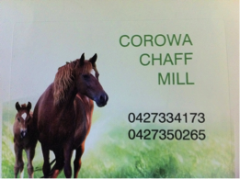

Indemnity forms must be filled in and signed prior to competing.

RING 10 SHOWJUMPING

SHOWJUMPING 9am Start
Showjumping Section conducted by the ‘Border District Showjumping Club’ under EA rules, maximum 3 starts per horse.

Classes’ 1 & 2 will be run concurrently.

Entry fee $5 all events.

1) 60cm-Junior riders only
Trophies 1st $15 2nd $10 & 3rd $5
2) 60cm Rutherglen Veterinary Clinic 60cm-Senior riders only
1st$20 2nd $10 3rd$5
3) 80cm Culcairn Butchery 80cm



1st$25 2nd $15 3rd$10
SADDLEWORLD ALBURY
2/410 Kiewa St.
Albury NSW 2640
ph 0260 212133
fax 0260 212143
saddleworldalbury@bigpond.com
www.saddleworld.com.au
4) 100cm Jirrima Performance Horses 100cm
1st$40 2nd $20 3rd $10
5) 110cm Border & District Showjumping Club 110cm
1st$50 2nd $30 3rd$20
Dr. Penny Reeves


The Culcairn Butchery Stewart Weily
46 Balfour St
Culcairn A Cut Above The Rest
Ph. 6029 8365 IT’S NO MISTEAK!
culcairnbutchery@hotmail.com

A SMALL ANIMAL PRACTICE

RING 11 Saddleworld Albury JUDGE:
DRESSAGE unnoficial 9am Start 1pm Finish
Judged to EFA rules. Entries to be received at sign in station by 10am

Entry fee, $5 NO PRIZEMONEY, NO RIBBONS, present dressage assessment sheet to judge prior to judging and pick it up of the pencillor, you will need to work out the maths.

1) Novice 2.3

2) Preliminary 1.3

PLEASE SUPPORT OUR SPONSORS AS HENTY SHOW SOCIETY NEEDS THEIR SUPPORT
Half page collagew

